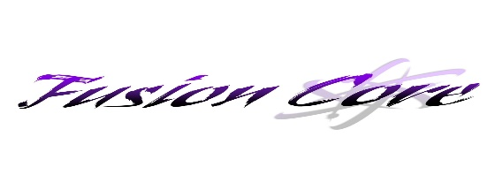
Fusion Core is a registered 501(c)(3) not-for-profit organization
www.fusioncore.org
Member Sponsorship Form
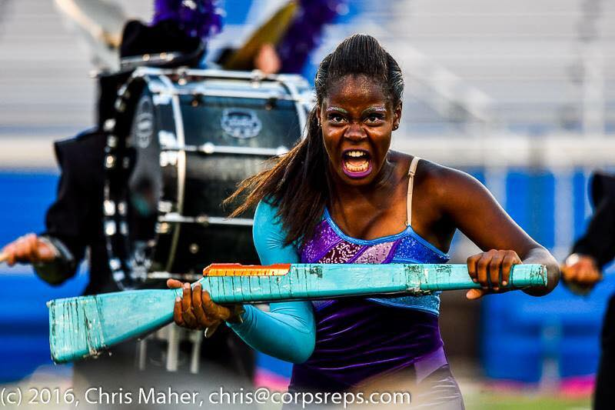
Fusion Drum Core is an organization dedicated to performance excellence in the field of competitive drum corps. The core competes throughout the northeast in the DCI All Age circuit (www.dci.org). Drum corps is a worldwide activity that is a combination of a sport and an art form, requiring participants to have physical strength, musical ability and poise to perform an exciting musical and visual show presented on a football field. Fusion Core enhances the community by bringing teens and adults together as a team in the corps’ percussion, brass and color guard sections.
The administration and staff of Fusion Core all grew up in the drum corps activity and have spent countless hours working to produce the most entertaining and competitive productions possible. Each year, we put all our energy and pour our hearts into an exciting, entertaining show to perform for fans and judges. The work that has culminated in those eleven minutes instilled confidence that has affected all facets of our lives, extreme pride in our accomplishments and have provided memories and friendships that will last a lifetime. We were fortunate to benefit from incredibly talented and truly inspirational leaders. We endeavor to provide the same resources and mentoring to today’s young people so that they may too experience the activity as we have. With your help, we can make this possible for this member.
Fusion Core is a 501c-3 not-for-profit organization that relies on fundraising, performance fees, and membership fees to pay for instruments, uniforms, instructors, transportation, practice facilities, insurance and overall operating expenses.
I, , am seeking sponsors to help fulfill my financial obligation which is $1800.00 for the 2024 season. Your donation would help me be a part of Fusion Core’s _____ production.
Sponsored amount:
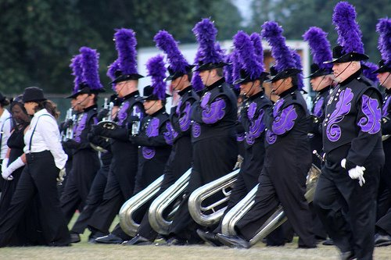
Sponsor name:
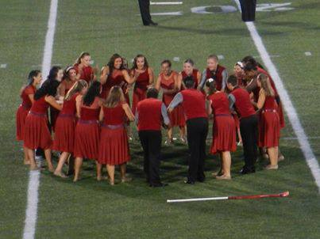
Address (if you would like a receipt): _____________
Please make checks payable to Fusion Core.
Mail to: 57 Turner Street, Dover, NJ 07801
Thank you!

